ARCHITECT REVIEW
SALDEV-1475 | OOB Grouped Lines on Amend and Renew
FlywirePartial | Read-only lifecycle investigation and architect assessment
Source | FlywirePartial | Sandbox org 00DhG0000000jOXUAY
Test records | Q-37942 | Contract 00021743 | Q-37946 | Q-37950
Review date | 28 August 2026
Validation mode | Read-only SOQL and source review; no deployment or record changes
Decision | CHANGES REQUESTED - Ramped result confirmed; required cases remain untested
Boundary | No records, metadata, deployment, activation, or pricing recalculation were changed

ARCHITECT DECISION
Do not close SALDEV-1475 as fully complete. The ramped-group lifecycle is confirmed and matches Salesforce CPQ expected behavior, but the required non-ramped lifecycle case and populated NetSuite-ID case were not executed.

Acceptance outcome
# | Scope | Result | Evidence
1 | Subscription group identity | Indirect only | No group ID is stored on Subscription. Lineage is Subscription -> Source Quote Line -> original Quote Line Group.
2 | Groups on amendment | No | Q-37946 has five lines, Group Line Items=false, zero groups, and every SBQQ__Group__c is null.
3 | Groups on renewal | No | Q-37950 has four lines, Group Line Items=false, zero groups, and every SBQQ__Group__c is null.
4 | Final-group assumption | Rejected | Renewal has three Domestic Payments lines mapped to three distinct subscriptions, not one consolidated final-group line.
5 | Early renewal timing | Header pass | Although generated before Year 3 starts, Q-37950 correctly covers 24-Sep-2029 through 23-Sep-2030.
6 | Non-ramped / NS ID | Not tested | Original data contains only ramped groups; every NS_ID__c is null, so both required behaviors remain unverified.

Observed amendment and renewal path
Salesforce CPQ preserves subscription-level lineage but does not preserve original Quote Line Groups. Flywire custom group-date logic only runs when groups exist.
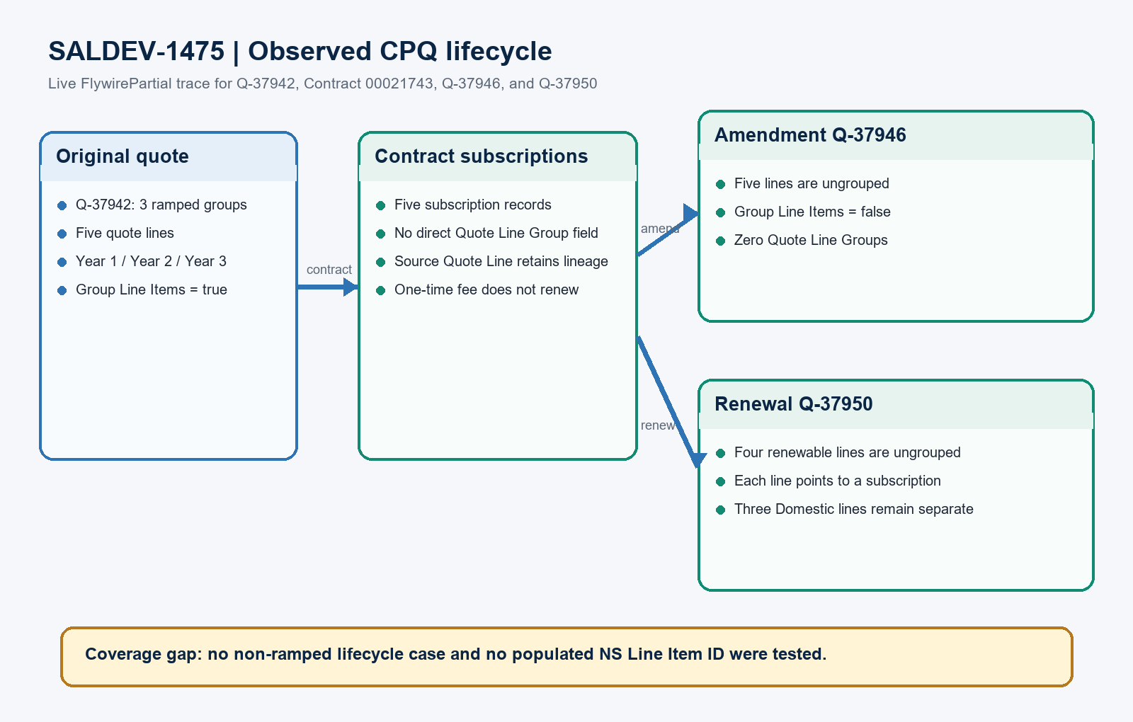
Figure 1. SALDEV-1475 observed CPQ lifecycle in FlywirePartial
DESIGN READING
Green is verified live. Blue is the original quote structure. Amber is required follow-up evidence.

Detailed investigation findings

1. Named-record evidence
Record set | Observed result | Evidence
Target org | FlywirePartial | Org 00DhG0000000jOXUAY; Enterprise Edition sandbox; API 67.0.
Original quote | Q-37942 | 5 lines | Three ramped groups: SUP Year 1, Year 2, and Year 3; dates span 24-Sep-2026 to 23-Sep-2029.
Contract | 00021743 | 5 subscriptions | Latest End Date behavior; renewal term 12; subscriptions retain source Quote Line links, not group IDs.
Amendment | Q-37946 | 5 ungrouped lines | All original subscription lines appear, including the one-time implementation fee; no groups were recreated.
Renewal | Q-37950 | 4 ungrouped lines | Three Domestic Payments lines plus one Platform Fee; one-time Implementation Fee is absent.

2. Exact lifecycle outcomes
Lifecycle stage | Result | Live evidence
Original grouped quote | Verified | Q-37942 has Group Line Items=true, three group records, and all five lines linked to a group.
Amendment quote | Expected OOB | Q-37946 has Group Line Items=false and no Quote Line Group records. Salesforce Help KA 004518583 confirms this is expected CPQ behavior.
Renewal quote | Expected OOB | Q-37950 has Group Line Items=false and no Quote Line Group records; each line links to a renewed Subscription.

3. Price, NetSuite, and coverage findings
Area | Status | Evidence / required action
Renewal lineage | Verified | Each renewal line has SBQQ__RenewedSubscription__c; three Domestic lines map to SUB-0067610, SUB-0067613, and SUB-0067614.
Platform price | Observed | SUB-0067611 has Renewal Price 10,000; its renewal line has NS Billing Price 10,000 and Net Price 360,000.
Early generation | Observed | Renewal header starts one day after the latest subscription end date. Generation before Year 3 start did not shift the header period.
NS Line Item ID | Blocked | NS_ID__c is null on all five Subscriptions and all renewal lines; populated-ID propagation cannot be concluded.
Non-ramped group | Missing | No Allow Product Ramping=false group exists in the named original quote. Execute the second required contract lifecycle.

Quote group and subscription lineage architecture
Quote Line Group is a quote-only container. Contracting creates independent Subscriptions that retain source Quote Line lineage; amendments and renewals create ungrouped lifecycle lines.
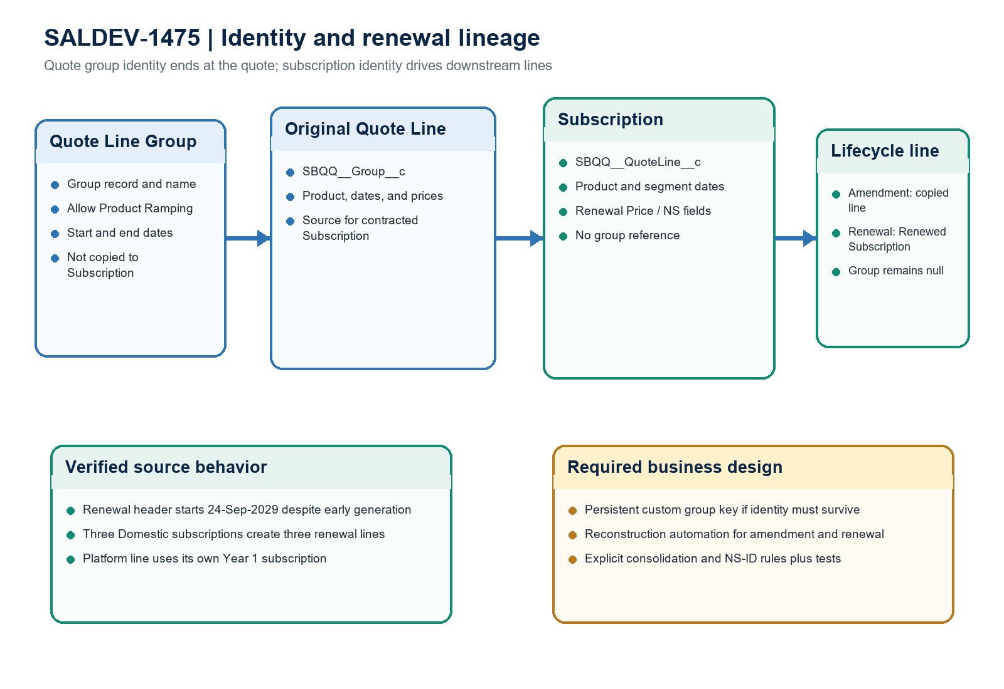
Figure 2. SALDEV-1475 identity boundary and renewal-line lineage
Architect interpretation: the live data and Salesforce guidance agree that groups do not survive amendment or renewal. Preserve identity only through an explicit custom data model and reconstruction design.

Required completion gates
Gate | Required action | Owner | Evidence needed
1 | Run non-ramped lifecycle | QA / Developer | Create Allow Product Ramping=false groups, contract, amend, and renew; capture group counts and line-level links.
2 | Test populated NS IDs | Integration / QA | Use subscriptions with populated NS Line Item ID and compare subscription, amendment, and renewal values field by field.
3 | Confirm renewal intent | Product owner / Architect | Choose whether three stepped subscriptions should remain separate or consolidate to the final commercial period.
4 | Define persistent group key | Solution architect | If lifecycle grouping is required, define a custom identifier on source lines/subscriptions and deterministic reconstruction rules.
5 | Test pricing variants | CPQ QA | Cover non-zero prices by ramp year, renewal pricing methods, uplift, and renewal before each segment start.
6 | Coordinate linked stories | Product owner | Align the chosen behavior with SALDEV-1439 and SALDEV-1493; do not treat this investigation as implementation approval.

Ready-to-paste architect response
STORY COMMENT
Architect review completed for SALDEV-1475 in FlywirePartial using Opportunity OOB-CPQ-Learning-Shrey-20260821, original Quote Q-37942, Contract 00021743, Amendment Quote Q-37946, and Renewal Quote Q-37950. Salesforce CPQ did not copy or recreate Quote Line Groups: five Subscriptions trace indirectly through their Source Quote Lines, while both lifecycle quotes have Group Line Items=false, zero groups, and null line Group IDs. The final-group assumption is rejected because Q-37950 contains three separate Domestic Payments lines, each linked to a different Subscription. The Platform Fee line links to SUB-0067611, whose Renewal Price is 10,000; the renewal line has NS Billing Price 10,000 and Net Price 360,000. The one-time Implementation Fee does not renew. The renewal header correctly spans 24-Sep-2029 through 23-Sep-2030 even though renewal was generated before the final segment started. Changes Requested: complete the required non-ramped lifecycle test and a populated NS_ID__c test before closing the investigation. If group identity must survive, use a persistent custom identifier and deterministic reconstruction automation coordinated with SALDEV-1439 and SALDEV-1493.

Evidence boundary
This assessment combines the SALDEV-1475 ticket text, Salesforce Help KA 004518583, read-only FlywirePartial schema and record queries, and local source review. No records, deployments, activations, pricing calculations, quick deploys, or org metadata changes were performed.

